Netflix Power BI Dashboard
Name: Douzi Narmeen Khanam
Course: Microsoft Certified: Power BI Data Analyst Associate
Date: 11-02-2026

Executive summary
This single-page interactive report explores the Netflix titles dataset (Kaggle) to show title counts, average ratings, vote totals, genre comparisons and a world map of title origins. The dashboard is designed for quick insights at a glance and supports drilling down by country, genre and title type.
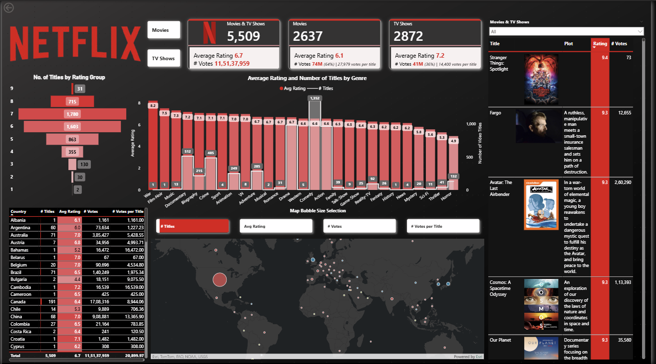
Objective
To build a one-page Power BI report that answers:
- Which genres have the most titles and how do their average ratings compare?
- Which countries produce the most titles and how do ratings/votes vary by country?
- What are the top titles by rating and by votes?

Data
Source: https://www.kaggle.com/datasets/snehaanbhawal/netflix-tv-shows-and-movie-list
Fields used (high level): ID, Title, Type, Country, Start Year, Runtime, Genres, Rating, Votes, Plot, Image URL.
Data quality notes: Some fields contained "\N" placeholders, nulls and multi-value genre strings that were cleaned and normalized in Power Query.

Power Query / Preprocessing steps
I performed the following transformations in the Power Query Editor:
- Changed types - imdb_id to text, title to any, popular_rank to int, certificate to any, startYear to int, endYear to int, episodes to int, runtime to any, type to text, origin_country to text, language to text, plot to text, summary to text, rating to number, numVotes to int, genres to text, isAdult to int, cast to text, image_url to text.
- Removed columns - popular_rank, certificate, endYear, episodes, langauge, summary, isAdult, cast.
- Renamed columns - imdb_id to ID, title to Title, startYear to Start Year, runtime to Runtime, type to Type, origin_country to Country, plot to Plot, rating to Ratings, numVotes to Votes, genres to Genres, image_url to Image URL
- Changed types - ID to text, Title to text, Start Year to text.
- Changed types - Type to text, Country to text, Plot to text, Ratings to number, Votes to int, Genres to text, Image URL to text.
- Replaced values "\N" in Runtime column to null
- Replaced values "\N" in Genres column to null
- Changed type - Runtime to int
- Filtered values in Type column by omitting null, short, video, videoGame
- Renamed columns - Ratings to Rating
- Filtered values in Rating column by removing null and in Country column by removing "-"

Data model & measures

1. Calculations table
I created a dedicated Calculations table that houses the key measures used across the report. The table centralizes aggregation logic (title counts, votes, and averages), label/format measures used by the leaderboard, and dynamic color measures for conditional formatting. Centralizing these measures keeps the report performant and makes it easy to reuse logic across visuals, slicers and the map parameter.
Measures (brief descriptions)
- # Movie Titles — distinct count of titles where Type = "movie".
- # Movie Votes — sum of Votes for movie-type titles.
- Titles — total distinct titles (all types).
- # TV Titles — distinct count of titles where Type = "tv show".
- # TV Votes — number of Votes for TV-type titles.
- # Votes — number of Votes for all titles.
- # Votes per Title — DIVIDE([# Votes], [Titles]) (average votes per title).
- % Movie Votes Label — formatted text showing movie votes as a percent of total votes (used in KPI).
- % TV Votes Label — formatted text showing TV votes as a percent of total votes.
- Avg Rating — average rating across the current filter context (used in charts and KPIs).
- Dynamic Rating Fill — returns a background color (hex) based on rating thresholds (used to set visual fill color dynamically).
- Dynamic Rating Font — returns a text/font color depending on the rating (ensures contrast/readability with the fill).
- Movie Avg Rating — average rating filtered to movies only.
- TV Avg Rating — average rating filtered to TV shows only.

2. Calculated Columns created in the main Listings Table
- Genre
Extracts the first genre from the Genres text (everything before the first comma). This produces a single “primary genre” per row so the dataset can be grouped and charted easily (used in the genre comparison visual and genre slicers).
- Listing Type
Normalizes raw Type values into two clean categories — Movie or Television — by mapping several source values into these two groups. This simplifies comparisons (Movies vs TV Shows) and drives the movie/TV KPIs and filters.
- Rating Group
Buckets the numeric Rating into discrete groups (0, 1, 2, …, 9) where each bucket represents a one-point rating interval. These buckets are used to build the rating-distribution visual and to label rating ranges.
- Listing Type Filter Value
Creates friendly filter labels that match report controls (maps Movie → Movies, Television → TV Shows, otherwise blank). This column is used by slicers/buttons so the visuals switch cleanly between the two report categories.

Why these columns exist?
These calculated columns standardize and de-normalize row-level values so visuals, slicers and conditional rules work predictably. Having a single primary genre, a normalized listing type, and rating buckets makes aggregation, filtering and conditional formatting straightforward — especially for static page-level slicers and the map parameter.

3. Map parameter
I created a parameter and exposed it through a button/slicer to let the map switch the bubble sizing between # Titles, Avg Rating, # Votes and # Votes per Title.

Dashboard layout & component walkthrough
Below is a visual walkthrough of the single-page layout (use the attached full screenshot while reading this section):
- Header / Branding (left): Large Netflix wordmark used for visual identity.
- KPI cards (top center): Totals for Movies & TV Shows, Movies and TV Shows showing average rating and total votes — provide quick dataset stats.
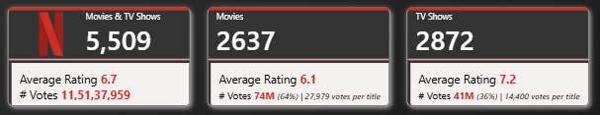
- Rating distribution (left middle): A stacked/funnel look showing count of titles by rating group (helps see where titles concentrate).
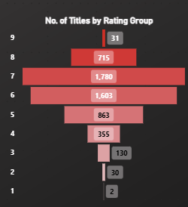
- Genre comparison (center): Clustered bar chart showing average rating per genre with an overlaid count of titles. This is useful to spot genres that have high ratings but few titles (quality vs quantity).
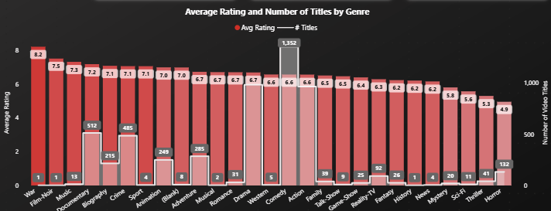
- Country table (bottom left): Table listing # Titles, Avg Rating, # Votes and # Votes per Title — good for sorting and selecting a specific country.
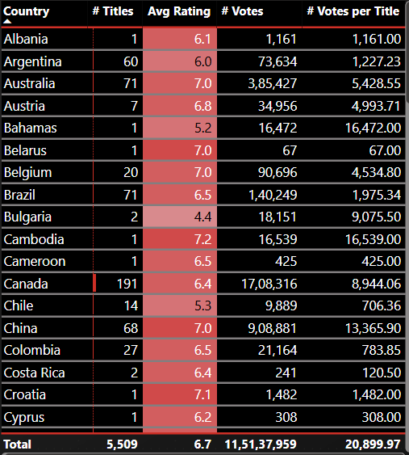
- World bubble map (center bottom): An ArcGIS bubble map where bubble size/metric is controlled by the parameter button. Useful to see geographic concentration.
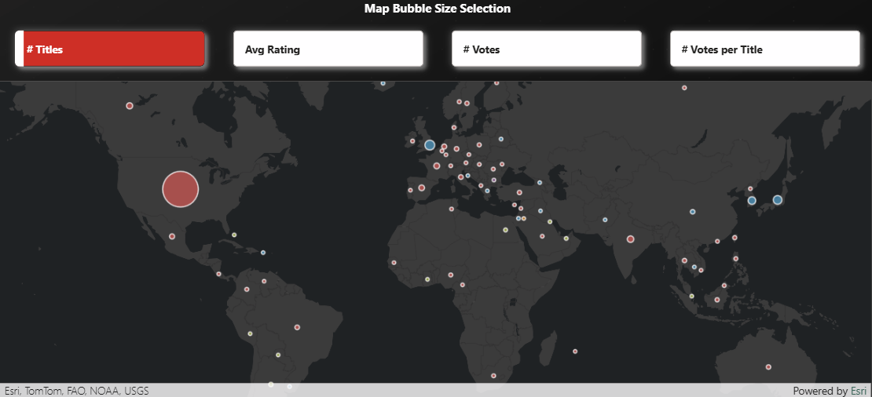
- Leaderboard (right): Vertical list with poster images, plot, rating and vote count — highlights top individual titles for quick reference.
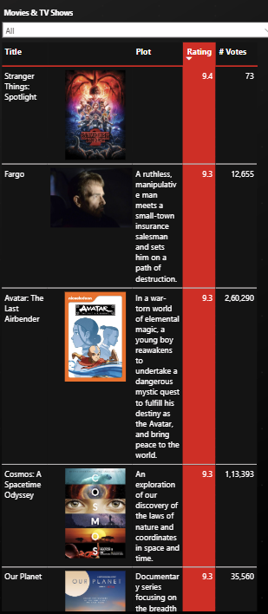
Each visual is interactive: clicking a genre or a country filters related visuals; the parameter button toggles map bubble sizing.

Key insights & observations
- Top genres by count: The top three genres are War, Film-Noir, and Music.
- High rating vs low count: The highest rated genres which are War, Film-Noir and Music have least number of titles.
- Titles by rating group: Majority of the titles have a rating of 6 and 7.
- Country concentration: A small set of countries (United States, the UK, Japan, and South Korea) produce the majority of titles.
- Top titles: The leaderboard highlights titles with both high ratings and high vote counts. Stranger things is the highest rated show. The Lord of the Rings has gained the most votes.

Limitations & recommended next steps
Limitations
- The dataset is ~4 years old and may not reflect current Netflix inventory.
- Geocoding & map precision: Because the report was built and published using my university Power BI account, the native mapping service Azure Maps was not available under the subscription. I used the ArcGIS visual instead — ArcGIS provides strong mapping support but, in this configuration, I observed slightly less precise country/bubble placement compared to Azure Maps.
- Posters and image URLs are external and may change or fail to load when the report is shared.

Steps followed in Report Creation
- Imported the Kaggle CSV into Power BI Desktop.
- Applied the Power Query steps listed in the Preprocessing section above.
- Data model: loaded the cleaned table in power bi desktop.
- Created measures (examples listed in the Data model & measures section).
- Visual build order: Rating distribution → KPIs → Leaderboard → Genre chart → Country table → Map (ArcGIS)
- Publish: published the report/dashboard to my workspace using my university ID. (Note: mapping visuals depend on workspace subscription settings)

Appendix — Screenshots
- Dashboard
- KPI cards
- Genre chart closeup
- Country table closeup.
- Rating Distribution – Funnel Chart.
- World bubble map.
- Leaderboard with posters.

References
- Original dataset: https://www.kaggle.com/datasets/snehaanbhawal/netflix-tv-shows-and-movie-list
- Tutorial followed: https://www.youtube.com/watch?v=InYxu2h7o6I – Power BI Bro

